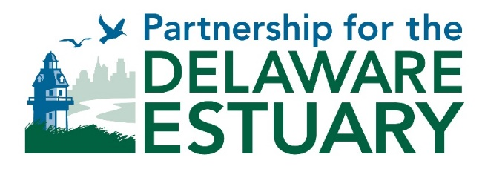
Joint Meeting of the
Estuary Implementation Committee (EIC) and the
Science & Technical Advisory Committee (STAC)
December 2, 2021, 10:00 AM – 2:00 PM

Zoom Link: https://us02web.zoom.us/j/89977056364

Agenda

10:00 Welcome & Introductions (15 minutes)
- Kathy Klein (EIC), Dorina Frizzera (STAC)

10:15 Monitoring Inventory and Needs Assessment (MINA) Report - LeeAnn Haaf, (15 minutes)

10:30 2022 TREB progress update - LeeAnn Haaf (15 minutes)

10:45 2021 PDE Summit Recap, 2023 PDE Summit Discussion Initiation – Leah Morgan, Danielle Kreeger (15 minutes)

11:00 DELEP Agreement Update – Kathy Klein (5 minutes)

11:05 NEP 2023 Budgeting/Base Funding and Infrastructure Act Supplemental Funding – Kathy Klein (20 minutes)

11:25 CCMP Implementation Tracking – TBD (15 minutes)

11:40 NEPORT Update – Haley Burns (10 minutes)

11:50 Urban Waters Federal Partnership Update – Erica Rossetti (10 minutes)

12:00 Waterborne Plastics Assessment and Collection Technologies (WaterPACT) in the Delaware River and Bay – Ben Maurer, Sustainable Oceans Lead, NREL (20 minutes)
- Ben leads the DOE-funded WaterPACT project across two national laboratories, working to (i.) assess, model and valuate the broad spectrum of plastics in five U.S. rivers in 2022 and 2023, and (ii.) build a technology development portfolio within sensing, collection, conversion, and redesign. Ben’s background is in environmental fluid dynamics, oceanography, engineering, and biology.

12:20 STAC Futures (25 minutes)

12:45 Roundtable Discussion (45 minutes)
This is an opportunity for DELEP partner reports and ad hoc sharing.
- Partnership for the Delaware Estuary (PDE)

- Delaware River Basin Commission (DRBC)
- Philadelphia Water Department (PWD)
- Pennsylvania Department of Environmental Protection (PADEP)
- New Jersey Department of Environmental Protection (NJDEP)
- Delaware Department of Natural Resources and Environmental Control (DNREC)
- US Environmental Protection Agency (EPA) Region 2 & 3
- Other partners

1:30 Other Business (30 minutes)
- Upcoming events and meetings
- Next EIC and STAC meeting dates

2:00 Adjourn

Attachments:
- 11.18.21 EIC Minutes DRAFT
- STAC-MACC Meeting Notes Draft 2021-06-09

